**Real Time Water Quality Monitoring & Analysis System**

**TEAM MEMBERS**

* **ALDRICH MARIAN A**
* **BARATH M**
* **ASHISH C**
* **AKASH SAI**

**AIM:**

To design and implement a real-time water quality monitoring and analysis system using the ESP8266 microcontroller, turbidity sensor, OLED display, LED, and supporting components to detect and alert when the water turbidity exceeds a safe level.

**COMPONENTS REQUIRED:**

1. ESP-8266
2. Turbidity Sensor
3. OLED
4. LED
5. Resistor
6. Breadboard

**ESP-8266:**

A compact Wi-Fi-enabled microcontroller used for controlling sensors and processing data. It can send and receive information wirelessly, making it ideal for IoT applications like water quality monitoring.

**Turbidity Sensor:**

A sensor that detects the presence of suspended particles in water, giving an indication of water clarity. It outputs an analog signal that the microcontroller reads and processes to monitor water quality.

**OLED:**

An energy-efficient screen that visually shows information such as turbidity levels and alerts. It communicates with the microcontroller using the I2C protocol and requires minimal power.

**LED:**

A light-emitting component that signals changes in water quality. When turbidity crosses a set threshold, the LED glows to alert users of possible contamination.

**Resistor:**

A passive component used to limit the current flowing to the LED, ensuring that it operates safely without overheating or burning out.

**Breadboard:**

A reusable prototyping board that allows electronic components to be connected without soldering. It is mainly used for testing, learning, and quick modification of circuits

**Pin Table:**

| **Component** | **Pin on Component** | **ESP8266 Pin** | **Description** |
| --- | --- | --- | --- |
| Turbidity Sensor VCC | VCC | 3.3V | Power supply for the sensor |
| Turbidity Sensor GND | GND | GND | Ground connection |
| Turbidity Sensor A0 | Analog output | A0 | Reads turbidity data via ADC |
| OLED Display VCC | VCC | 3.3V | Power supply for OLED |
| OLED Display GND | GND | GND | Ground connection |
| OLED Display SDA | Data line | GPIO4 (D2) | I2C data communication |
| OLED Display SCL | Clock line | GPIO5 (D1) | I2C clock communication |
| LED anode | + lead | GPIO0 (D3) | Turns ON/OFF depending on turbidity alert |
| LED cathode | - lead | GND | Ground for LED |
| Resistor (330Ω) | Series between GPIO and LED anode | Between GPIO0 and LED anode | Limits current to protect the LED |

**Circuit Connection:**

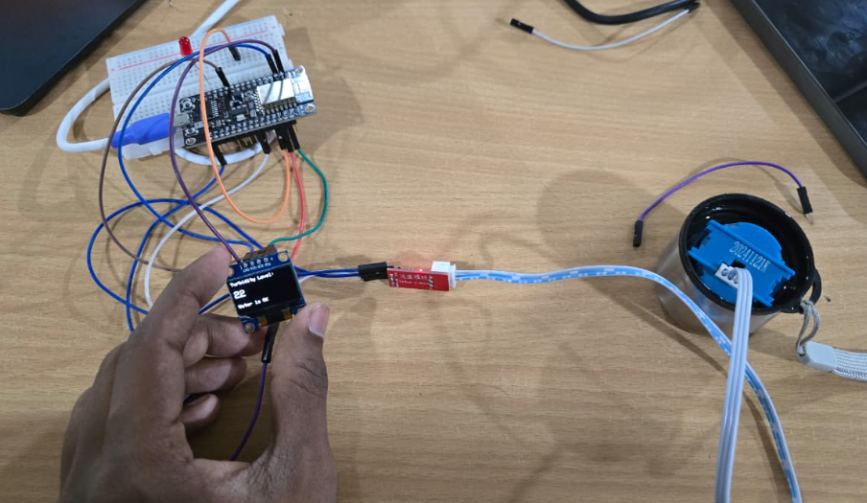

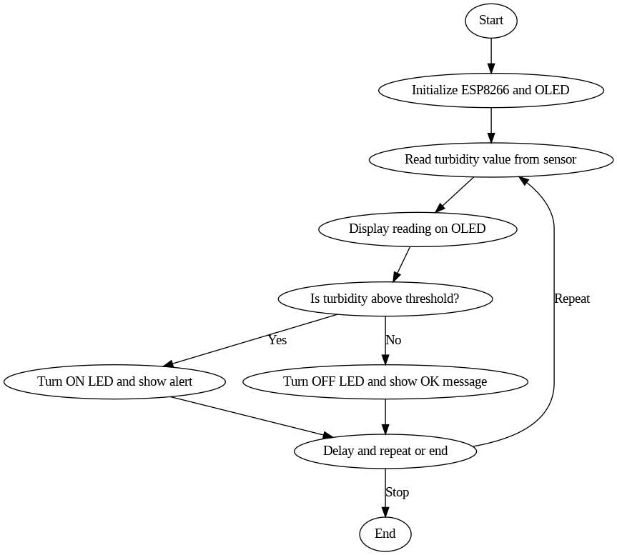**Flowchart:**

**Coding:**

#include <Wire.h>

#include <Adafruit_GFX.h>

#include <Adafruit_SSD1306.h>

// OLED display settings

#define SCREEN_WIDTH 128

#define SCREEN_HEIGHT 64

#define OLED_RESET -1

Adafruit_SSD1306 display(SCREEN_WIDTH, SCREEN_HEIGHT, &Wire, OLED_RESET);

// Pin definitions

const int turbidityPin = A0; // Analog input from turbidity sensor

const int ledPin = D3; // Digital output to LED (through resistor)

// Threshold for turbidity alert

const int turbidityThreshold = 400; // Adjust this based on calibration

void setup() {

Serial.begin(115200);

// Initialize the LED pin

pinMode(ledPin, OUTPUT);

digitalWrite(ledPin, LOW);

// Initialize the OLED

if(!display.begin(SSD1306_SWITCHCAPVCC, 0x3C)) {

Serial.println("OLED initialization failed!");

while(true);

}

display.clearDisplay();

display.setTextSize(1);

display.setTextColor(SSD1306_WHITE);

display.setCursor(0,0);

display.println("Water Quality Monitor");

display.display();

delay(2000);

}

void loop() {

// Read turbidity value from sensor

int turbidityValue = analogRead(turbidityPin);

// Display the turbidity value on OLED

display.clearDisplay();

display.setCursor(0,0);

display.println("Turbidity Level:");

display.setTextSize(2);

display.setCursor(0,20);

display.print(turbidityValue);

display.setTextSize(1);

// Check if turbidity exceeds threshold

if(turbidityValue > turbidityThreshold) {

digitalWrite(ledPin, HIGH); // Turn on LED

display.setCursor(0,50);

display.println("ALERT! High Turbidity");

} else {

digitalWrite(ledPin, LOW); // Turn off LED

display.setCursor(0,50);

display.println("Water is OK");

}

display.display();

delay(1000); // Update every 1 second

}

**Execution:**

